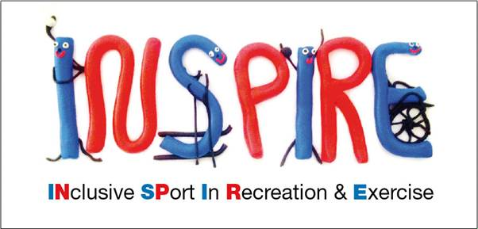

**Equity policy statement**

***inspire***

The essence of good ethical conduct and practice is summarised below.

All volunteers must:

|  |  |  |
| --- | --- | --- |
|  | This Club is committed to ensuring that equity is incorporated across all aspects of its development.  In doing so it so acknowledges and adopts the following Sport England definition of sports equity: | |
|  | ***Sports equity is about fairness in sport, equality of access, recognising inequalities and taking steps to address them. It is about changing the culture and structure of sport to ensure it becomes equally to***  ***everyone accessible to everyone in society.*** |
|  | The Club respects the rights, dignity and worth of every person and will treat everyone equally within  the context of their sport, regardless of age, ability, gender, race, ethnicity, religious belief, sexuality or social/economic status. | | |
|  | The Club is committed to everyone having the right to enjoy their sport in an environment free from  threat of intimidation, harassment and abuse. | | |
|  | All club members have a responsibility to oppose discriminatory behaviour and promote equality  of opportunity. | | |
|  | The Club will deal with any incidence of discriminatory behaviour seriously, according to club  disciplinary procedures. | | |