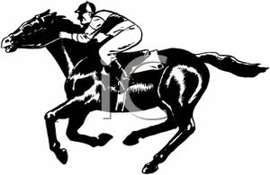

Forget Sandown or Kempton Park - discover 2014’s hot new racing location in Surbiton!
FAMILY RACE NIGHT
Friday 10th October 2014
In aid of Inspire Sport & Money for Milk
At Surbiton Assembly Rooms, Surbiton KT6 4RT by kind permission of Surbiton High School
Starts at 7pm, first race at 7.30pm
Tickets £12 including a fish and chip supper
Become a Race Horse Owner for £10
Bar Prizes Ice Creams
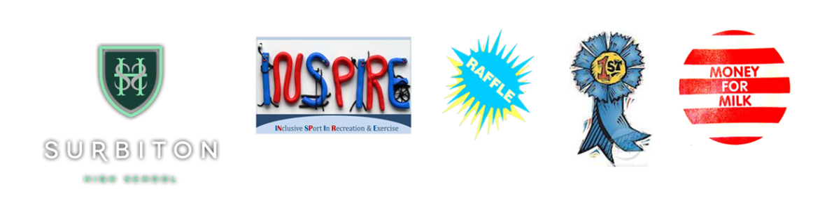
www.inspire-sport.co.uk is open to anybody with a disability or special need from 8-80, giving the opportunity to play sport in a fun atmosphere in the Kingston/Chessington area.
www.moneyformilk.co.uk was set up in 2009 to help support Baphumelele Children's Home, near Cape Town, South Africa
---------------------------------------------------------------------------------------------------------------------
No of Tickets ….………@ £12 ………… (Tables seat up to 10 – bring friends or we can make up tables)
Number of Race Horses @£10 each ………… Names of Race Horses……………………………………………….
.……………………………………………………………………………………………………………………………………………………………………….
Name ………………………………………………………………………………………….
Address ………………………………………………………………………………………………………………………………………....
…………………………………………………………………………………………………………………………………………………………..
Email …………………………………………………………………. Telephone …………………………………..……………

